Joseph Rajewski

New Build View

Default Build View

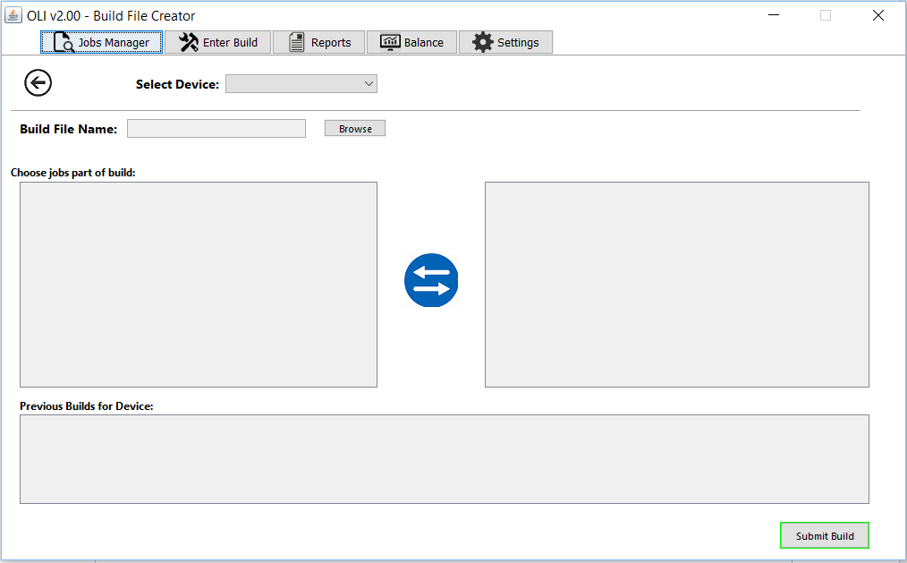

After selecting a device

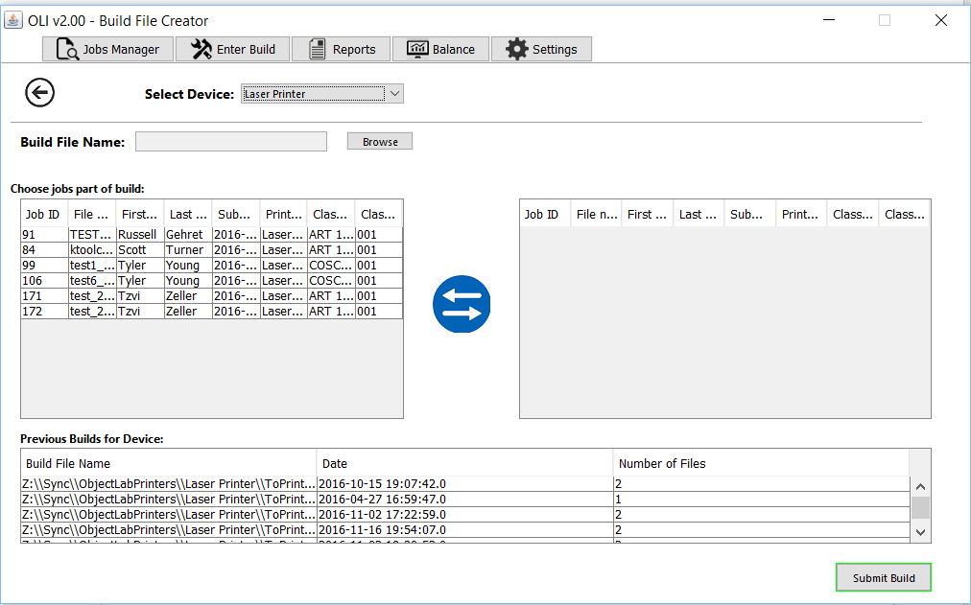

After adding with swap button

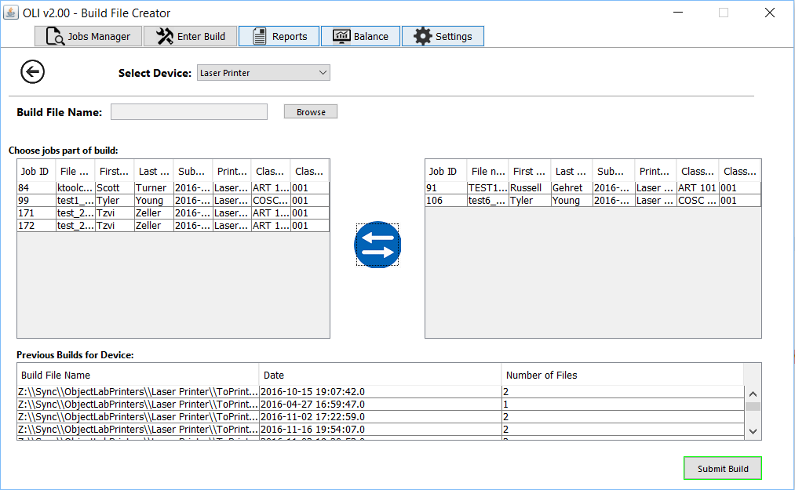

For Developers:

Specs

* On the surface, very similar to previous version of Build View
  + Left table has approved files for the selected device
  + Right table has files that are to be in the new build
* Bottom table is now a table filled with records of previously created build files for the selected device
  + Previously, this table was for adding input to a build file
  + Replaced based on feedback from last interview, based on this requirement:
    - “Date and number of files. Josh is intentionally not giving us the build-specific data at this time. It is very complicated and he doesn’t know if he wants to leave this to the application to handle.” -Josh
* New button in center instead of 2 buttons to move from right table to left table or vice versa
* User is required to browse for a build file for a build submission

Known Issues:

* GUI
  + Margin resizing required
  + Button design adjustment likely
  + Center the menu bar
  + Selected row is not highlighted
* General
  + Swap button allows for one option to be select on one side to move
    - Processing takes too long (currently 3+ seconds)